# Users Guide

**System objective**

This system is made to calculate how many stops Star Wars starships need to cover a given distance

**System requeriments**

Windows computer with Microsoft .NET Framework 4.5 or higher

**System operation**

To execute the program, double click on the file “StarWarsTestKneat.exe”

Wait some seconds and a console window will appear, like this

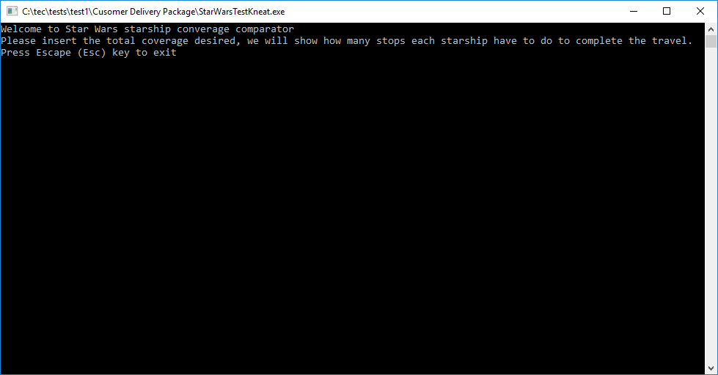

Enter the desired distance in MGLT* and press Enter

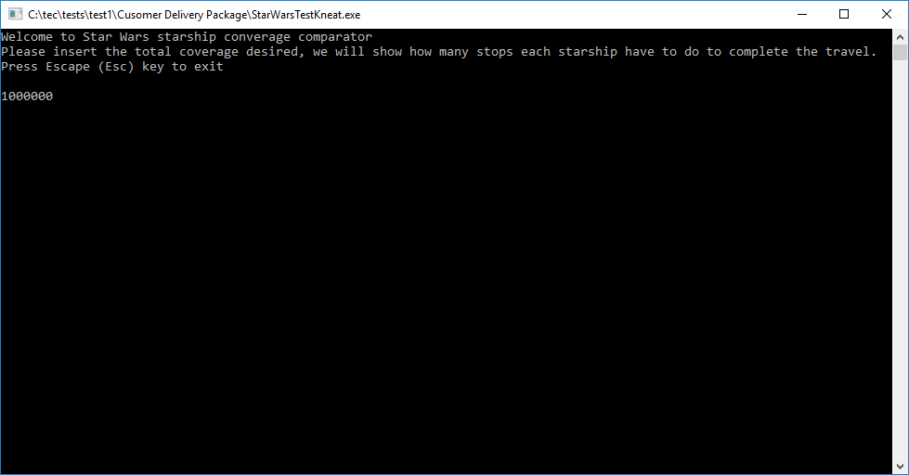

The system will fetch data on server to do the calculations, and the result is showed as text in the console window, after system finishes you can enter a new distance or exit pressing Escape(esc) key.

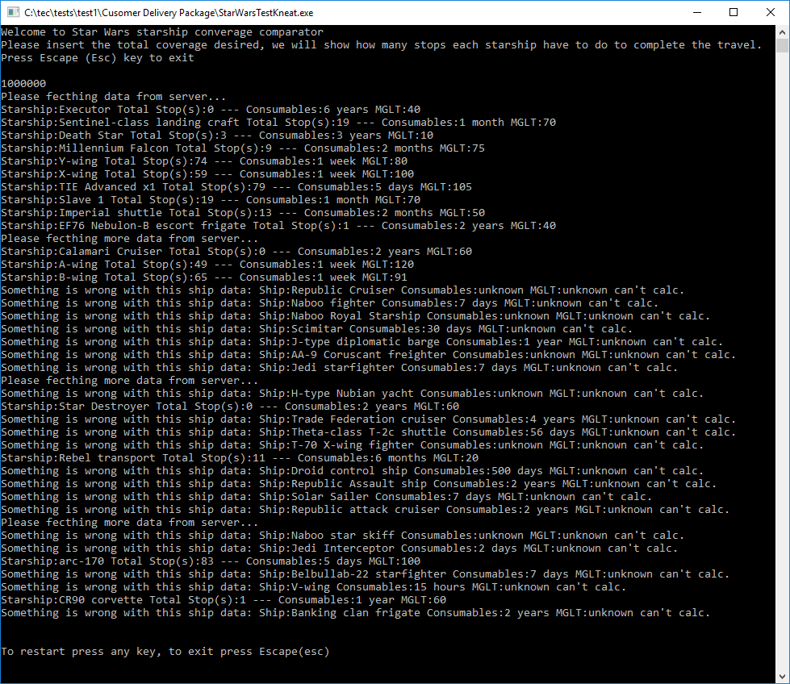

MGLT*: http://starwars.wikia.com/wiki/Megalight_per_hour

The megalight per hour (abbreviated MGLT) was a unit used to measure the relative sublight speed of [starships](http://starwars.wikia.com/wiki/Starship)in [realspace](http://starwars.wikia.com/wiki/Realspace). For example, the [RZ-1 A-wing interceptor](http://starwars.wikia.com/wiki/RZ-1_A-wing_interceptor) was markedly faster (120 MGLT) than the [BTL-A4 Y-wing assault starfighter/bomber](http://starwars.wikia.com/wiki/BTL-A4_Y-wing_assault_starfighter/bomber) (70 MGLT).[[1]](http://starwars.wikia.com/wiki/Megalight_per_hour#cite_note-Graphics-0)

MGLT*: <https://swapi.co/documentation>

The Maximum number of Megalights this starship can travel in a standard hour. A "Megalight" is a standard unit of distance and has never been defined before within the Star Wars universe. This figure is only really useful for measuring the difference in speed of starships. We can assume it is similar to AU, the distance between our Sun (Sol) and Earth.

Any doubts you can send to this email “companyemail@company.com” with the subject “StarWarsTestKneat.exe”